September monthly report
……..........................................................
Dr. Pongkarn Chakthranont
โครงการ P2451496 งบยุทธ_CCU68_การต่อยอดและพัฒนาเทคโนโลยี Carbon capture and utilization (CCU) ที่มีความต้องการจากภาคอุตสาหกรรม และขับเคลื่อน National CCUS Alliance ร่วมกับเครือข่ายพันธมิตร
Sothearoth Heng
Under the supervision of
Dr. Pongkarn Chakthranont
ใบสั่งจ้างเลขที่ PO25005060
จ้างเหมาพัฒนางานจ้างพัฒนาการขยายขนาดเซลล์ไฟฟ้าเพื่อการผลิตแก๊สสังเคราะห์จาก CO₂ เชิงเคมีไฟฟ้า
งวดที่ 6: 1 September 2568 – 30 September2568

- To-do list in September
- Mitigation of water accumulation: 100cm² electrolyzer – CO₂ electrolysis of 0.5Ni-SAC under a pure CO₂ at 100mA/cm²: Increase CO₂ flow rate (500-1000 ml/min)
- Effect of Flow field configuration: Parallel vs Quad-serpentine
- Experimental Procedure
Synthesis of NiSAC by pyrolysis method
The synthesis of NiSAC catalyst was followed by our previous work. Initially, nickel phthalocyanine (NiPc), urea, and dicyanamide precursors were stoichiometrically weighed according to mass ratios of x:5:5, wherein urea and dicyanamide were maintained at 5 g each while varying the NiPc content (x = 0.25, 0.5, 1.0, and 2.0 g). Subsequently, the mixture was thoroughly mixed and ground until a homogeneous midnight blue powder was obtained. The fine powder was then transferred into a quartz boat covered with a capsule lid and subjected to polymerization at 800 °C (ramp rate = 10 °C·min⁻¹) in a horizontal tube furnace under an argon atmosphere (flow rate = 200 sccm) for 2 h. The as-prepared xNiSAC catalysts with different NiPc contents were finally obtained and labeled as 0.25NiSAC, 0.5NiSAC, 1.0NiSAC, and 2.0NiSAC.
Fabrication of IrO₂/TiPt felt anode electrode
The IrO₂/TiPt-felt anode electrode was prepared using a thermal deposition method involving multiple sequential steps. Initially, the TiPt felt (Purchased from ...) substrate was ultrasonically cleaned with deionized water and acetone to remove any surface contaminants. The cleaned substrate was subsequently etched in a 6M HCl solution at 90°C for 45 min to enhance surface roughness and adhesion properties. The dip-coating solution was prepared by dissolving 200 mg of IrCl₆·xH₂O in 18 mL of isopropanol (IPA) containing 10% v/v HCl (2 mL of conc. HCl). The etched TiPt felt substrate was then immersed in the dip-coating solution, followed by drying at 100°C for 5 min in an oven and subsequent calcination at 500°C for 10 min in a muffle furnace. After cooling to room temperature, the treated substrate was reweighed to determine mass gain. This dipping-drying-calcination cycle was repeated several times until the desired IrO₂ mass loading (1±0.2 mg/cm²) was achieved.

Preparation of NiSAC cathode electrode via spray coating method
The NiSAC gas-diffusion electrode was fabricated by spray coating onto Sigracet 39BB carbon paper or hydrophilic carbon cloth substrates. Typically, 150 mg of as-prepared NiSAC and 381 μL of XC-2 ionomer were ultrasonically dispersed in 10 mL of isopropanol (IPA) for at least 1 h to form a homogeneous dark colloidal suspension. The ink suspension was subsequently spray-coated onto a 6x6 cm² carbon substrate using an automated, custom-built spraying setup equipped with a syringe pump operating at a flow rate of 0.6 mL min⁻¹ on a hotplate maintained at 110°C, yielding a catalyst mass loading of 1.8 ± 0.1 mg.cm⁻².

Electrochemical measurements in membrane-electrode assembly (MEA) electrolyzer
100cm2 MEA electrolyzer operational set-up
A 100 cm² MEA electrolyzer was used to evaluate the CO2RR performance under modulated operating conditions. The Ni foam or IrO₂-TiPt felt (10.5 x 10.5 cm²), bipolar membrane (BPM, 15.6 x 16.8 cm²), and 0.5Ni-SAC (10.5 x 10.5 cm²) were employed as the anode, membrane, and cathode electrode, respectively. The MEA was assembled with 0.25µm PTFE gasket and tightened at a compression force of 25 Nm. 1.0 L of 0.25 M KOH was recirculated and used throughout the experiment as the anolyte at 100 ml/min. The humidified CO₂ gas stream was introduced into the cathodic inlet with a total CO₂ flow rate of 200-1000 ml/min. Prior the test, the electrochemical impedance spectroscopy (EIS) and Cyclic voltammetry were measured. Meanwhile, the cathodic outlet was directly injected into an online gas-chromatography for gas products analysis.

- Results
Mitigation of water accumulation by increasing cathodic inlet gas stream
According to our preliminary results, the water accumulation (liquid droplets) at the flow-field channel of the cathode side is the main issue that occurs with a parallel flow field design because the pressure drop at the exit is too low to force out the water, causing the flow field channels to become clogged and the reactant gases to be distributed unevenly, decreasing overall performance. We therefore increase the CO2 flow rate to help improve accumulated water removal in the BPM system. The CO2 electrolysis of the BPM system was evaluated under 1000ml/min of 50%CO₂/50N₂ cathodic gas stream and 0.25M KOH at 100 ml/min at 100 mA/cm² with a cell configuration of 0.5NiSAC (1.8 mg/cm²) |BPM| IrO₂-TiPt. The MEA electrolyzer was assembled with key components including a 0.3 µm PTFE gasket (10.5 × 10.5 cm²), a BPM size of 15.6 × 16.8 cm²., and a compression force of 120 in·lbs. As shown in Fig. 1, Increasing total cathodic flow rate by mixing 500ml/minCO₂ and 500ml/minN₂ resulted in abruptly inclined in cell voltage which might result from CO₂ starvation at the catalyst surface at high applied current density. Interestingly, once a pure 500ml/minCO₂ was replaced, the overall system still worked properly.
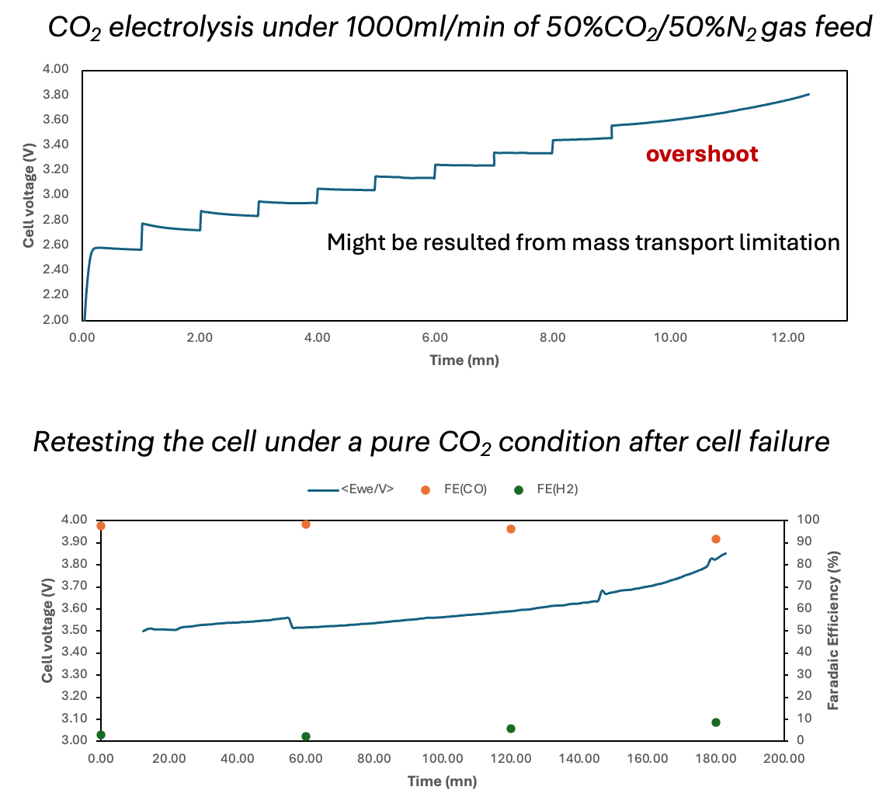

Figure 1. CO₂ electrolysis of 0.5Ni-SAC in a 100cm² MEA electrolyzer under 1000ml/min of 50%CO₂/50%N₂, 100ml/min 0.25M KOH, and IrO₂-TiPt anode at 100mA/cm²
Based on the above-mentioned result, we encountered that increasing the total flow rate by using the diluted 50%CO2 condition resulted in an immediate failure, thus a pure 1000ml/min CO₂ should be tried. Interestingly, as depicted in Fig. 2, further increasing the CO₂ flow rate to 1000ml/min enables to sustain a high FE(CO) > 90% for up to 13h before cell failure. Besides the improvement of system stability, the water accumulation was still observed at the GDE backside and flow-field channel which could be attributed to the gradual cell voltage rise over time and somehow caused a sudden overshoot above 4.0V, triggering HER activity.
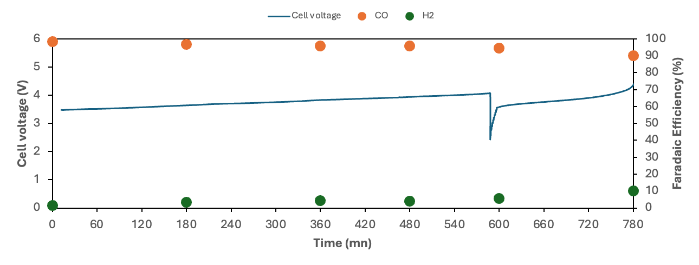
Figure 2. CO₂ electrolysis of 0.5Ni-SAC in a 100cm² MEA electrolyzer under 1000ml/min of pure CO₂, 100ml/min 0.25M KOH, and IrO₂-TiPt at 100mA/cm²

Effect of Flow field configuration: Parallel vs Quad-serpentine
To ascertain the effect of flow-field channel configuration, the cathodic flow-field channel was replaced by serpentine flow-field channel, while still using the parallel flow-field channel for the anode side. The electrochemical reduction of CO₂ was experimentally conducted using a BPM system deployed 0.5NiSAC as a cathode under a humidified pure 200sccm CO₂ with 2L of 0.25M KOH and IrO₂ anode at 100mA/cm². The BPM system with 0.5Ni-SAC initially achieved a maximum FE(CO) >95% at a full-cell voltage at 3.3V, and sustaining the FE(CO) >85% over 11h of operational duration. This result indicated the importance of the flow-field channel configuration for potentially removing accumulated droplets at the cathodic flow-field. However, the accumulated droplets are still observed in the serpentine flow-field which could be attributed to mass transport limitation over time, causing a marginal increase in over-potential and HER activity.
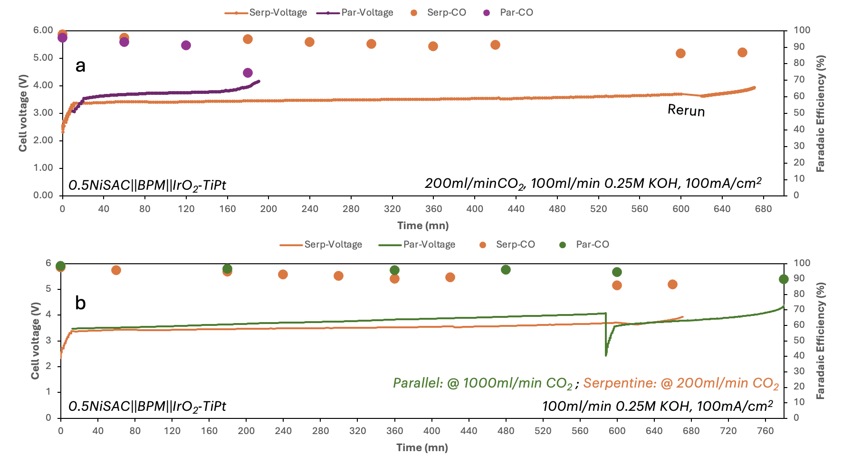
Figure 3. (a) Comparison of parallel and serpentine flow fields for CO₂ electrolysis of 0.5Ni-SAC in a 100cm² MEA electrolyzer under 200ml/min of CO₂, 100ml/min 0.25M KOH, and IrO₂-TiPt anode at 100mA/cm² and (b) under 200 and 1000 ml/min CO₂ flow rate, respectively.

- Upcoming tasks
  - 100cm² MEA electrolyzer – CO₂ electrolysis of serpentine-BPM system under a dried 200ml/min CO₂, 100ml/min of 0.25M KOH, and IrO2-TiPt anode at 100mA/cm²
  - 100cm² MEA electrolyzer – CO₂ electrolysis of serpentine-BPM system under a humidified 500ml/min CO₂, 100ml/min of 0.25M KOH, and IrO2-TiPt anode at 100mA/cm²

